Abstract

Examining the possibility of a Regional Public Transit system administered by the   
Southern Georgia Regional Commission to leverage economies of scale and improve   
overall access and mobility for residents in the 18 county service area

Regional transit plan

An Analysis and Feasibility Assessment



Contents

Chapter 1: Overview of the Rural Transit Plan 2

Chapter 2: Demographic Analysis 4

Chapter 3: Title VI of the Civil Rights Act of 1964 7

Chapter 4: Community Outreach 9

Chapter 5: Goals of 5311 Programs 13

Chapter 6: Transit Demand Analysis 16

Chapter 7: 5311 Financial Overview 19

Chapter 8: Potential Improvements 24

Chapter 9: Appendix 25

*The contents in this publication reflect the views of the author(s), who is (are) responsible for the facts and accuracy of the data presented herein. The opinions, findings, and conclusions in this publication are those of the author(s) and do not necessarily reflect those of the Department of Transportation, State of Georgia, the Federal Highway Administration, or the Federal Transit Administration. This publication does not constitute a standard, specification or regulation.*

*The Southern Georgia Regional Commission is an Equal Opportunity Employer and Service Provider. Qualified persons are considered for employment or for receipt of services without regard to race, color, religion, sex, sexual orientation, national origin, age, or disability.*

*This document is prepared in cooperation with the Georgia Department of Transportation, the Federal Highway Administration and Federal Transit Administration.*

# Chapter 1: Overview of the Rural Transit Plan

At the beginning of FY2019, the Georgia Department of Transportation (GDOT) approached the Southern Georgia Regional Commission (SGRC) about becoming a regional transit operator for all of Southern Georgia. This request matched the recommendations of the State Legislatures’ House Committee on Transit Governance and Funding, which resulted in House Bill 511 that promoted regional coordination within “mobility zones” primarily along regional commission boundaries (HB 511 was proposed in 2019 and did not pass, but remains an active bill for the legislature to consider in 2020).

Historically, the SGRC has created Transit Development Plans (TDPs) for each individual county in the Southern Georgia Region. These TDPs have been an effective resource for county elected officials and staff when discussing and answering basic questions about rural public transit in their respective counties. In a similar fashion to the TDPs, the Regional Transit Plan (RTP) will serve as a guidebook, examining what a regional, inter-county, public transportation system might look like. Currently, 11 of the 18 counties served by the SGRC have a 5311 rural public transportation system (Figure 1). All 18 counties have other transportation options under the Department of Human Services (DHS) Coordinated Transportation program and Medicaid Non-Emergency Medical Transportation services.

During a recent Federal Transit Administration’s (FTA) audit of GDOT, it was noted that within the SGRC area, at least four counties do not receive enough revenue from non-public sources to off-set a required cash match for federal funds to operate the system. According to FTA, each individual county must generate the local matching funds within the bounds of that county, and excess local matching funds may not be transferred between counties, even if neighboring counties utilized the same Third Party Operator (TPO) and the same regional source of local matching funds (in the case of the SGRC, DHS Coordinated Human Service Transit and Medicaid). It is estimated that the shortfall in funding for these counties would range from about $7,500 to more than $95,000. A concern is that if a county is required to pay a cash match for its rural public transit program the county may choose to instead not offer the program, leaving clients that depend on this transportation with fewer options than before. If these county-operated transit services were to cease operations the SGRC’s own Coordinated Human Services Transportation program serving clients for various Department of Human Service affiliated agencies would also be in jeopardy in those counties due to a lack of vehicles.

Regionalizing public transit leverages economies of scale while utilizing available funding sources to provide the matching funds needed to operate rural public transit services. Any of the DHS or Medicaid trips may utilize a 5311 funded vehicle for transport, and act as a Purchase of Service (POS) revenue source to offset local match requirements. This would allow residents to have improved access to resources such as education, employment, healthcare and other basic services available in other parts of the region.

Counties that currently have a public transportation system should expect negligible change from a regional system approach. It is expected that a Third Party Operator (TPO) will be selected by a Request for Proposal (RFP) bid as is the current process. Furthermore, in the event that a county decides not to opt into a regional system, the county will have the option of operating their own local transit system without any penalty.

## Why the change to a Regional Transportation system?

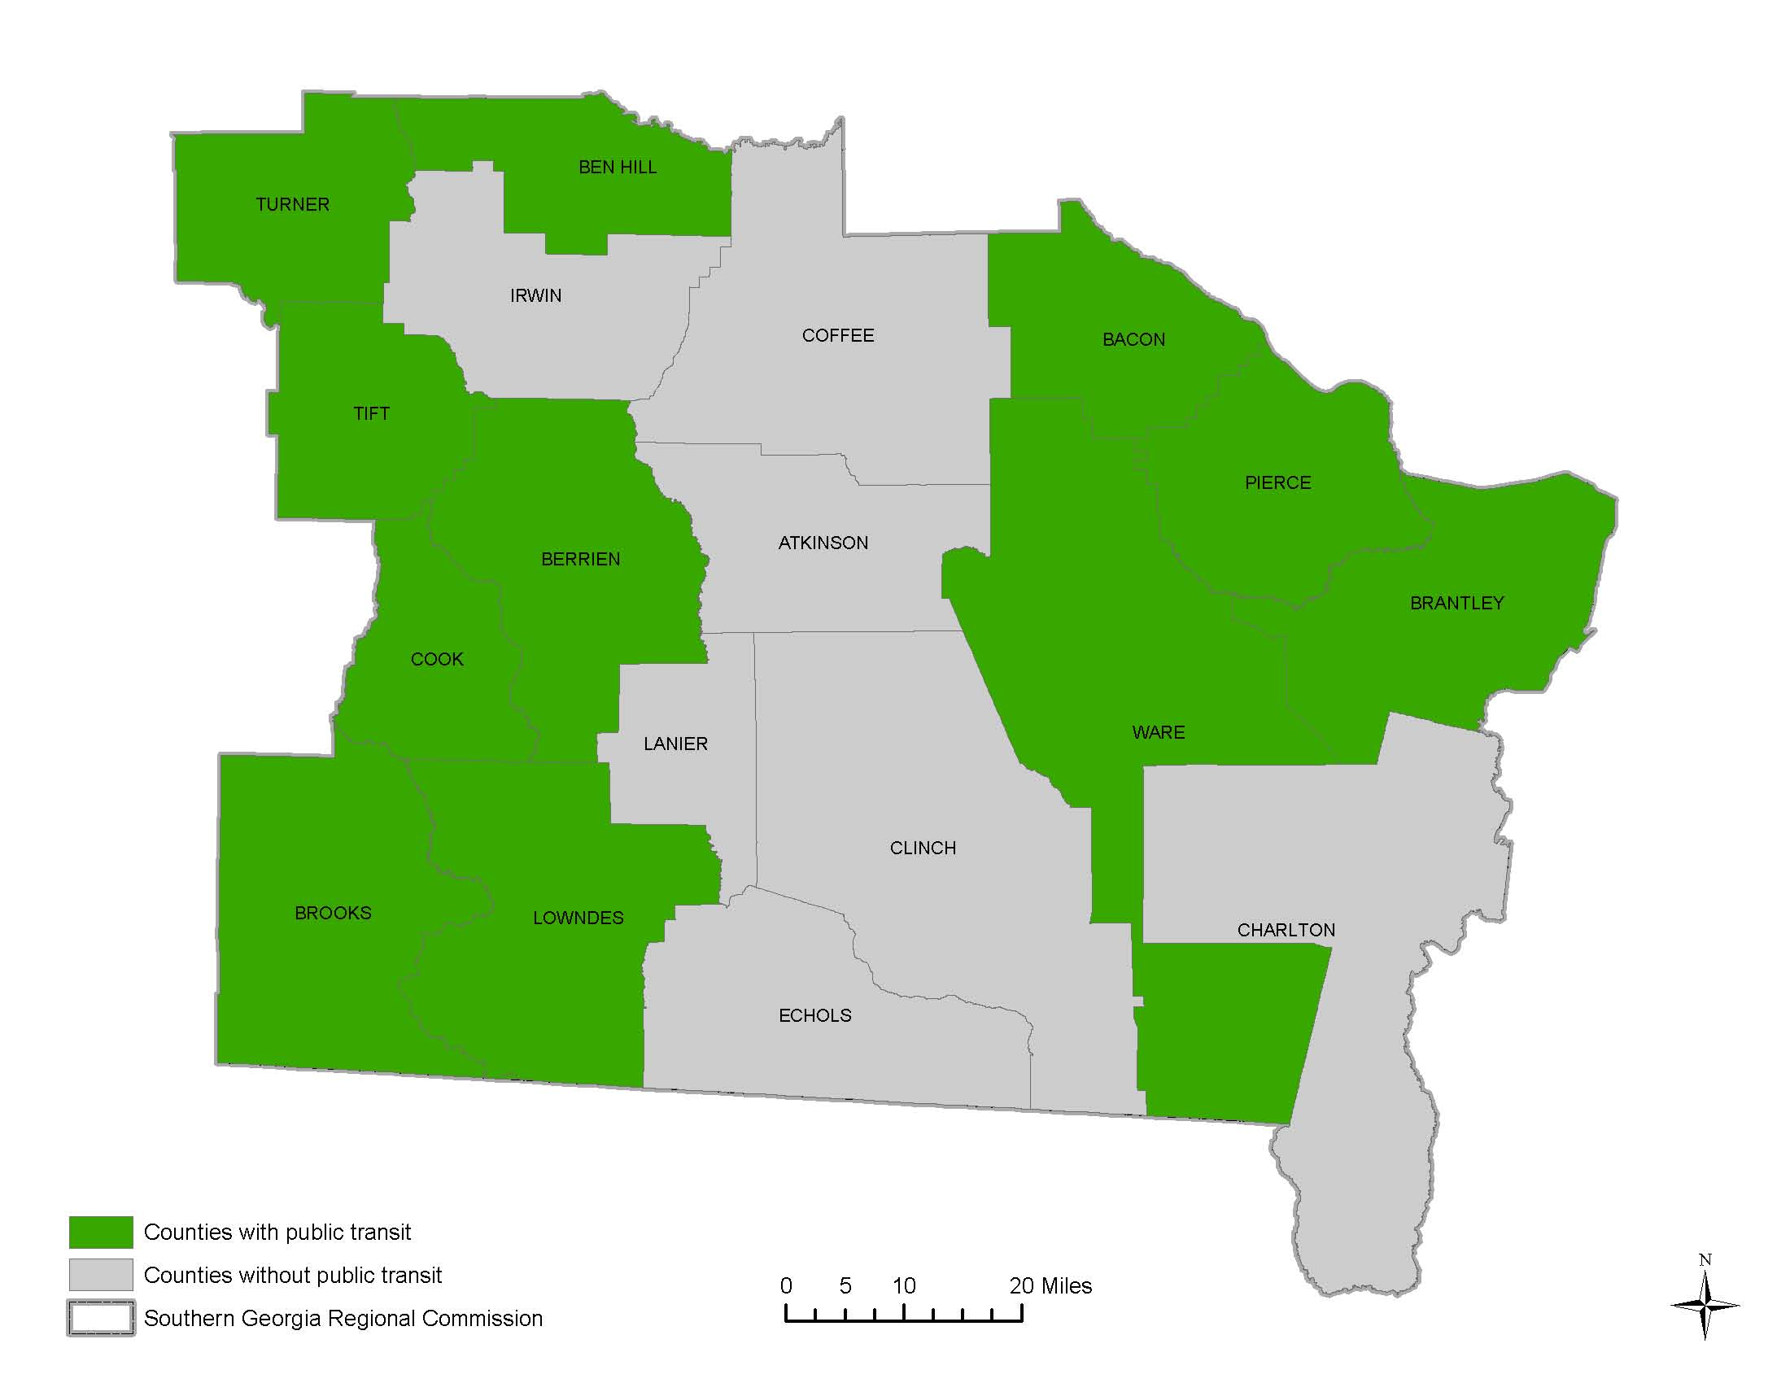Currently, 11 out of 18 counties have public transportation (Figure 1). While residents of these counties experience substantial benefits with increased access to healthcare and the overall improvement of inter-county transit, there are limitations to what county specific public transportation is able to accomplish. By opting into a regional public transit system, counties can expand access to resources such as education, employment, supermarkets, and healthcare providers beyond county lines. Due to economies of scale, regional public transportation has the potential to be more affordable than county specific public transportation for smaller counties. Counties that have a surplus of POS (Purchase of Service) funds will be able to share part of the burden of the maintenance and overhead fees of regional public transportation.

Figure 1: Map of Counties in Southern Georgia with and without Public Transit. All Counties have human services transportation through DHS and Medicaid

# Chapter 2: Demographic Analysis

The Southern Georgia region is largely rural. According to the 2017 U.S Census, there are an estimated 421,315 persons in the 18 counties of Southern Georgia. Table 1 presents the population demographics for the Southern Georgia Region and its peer regions (chosen for demographic, as well as operating regional transit areas). The ethnic makeup of the regions is also included in the table. According to the US Census, people of different ethnicities appear to have different transportation preferences. For example, persons of Latino or Hispanic descent were found to be more likely to carpool than other ethnicities.

|  |  |  |  |
| --- | --- | --- | --- |
|  | Southern Georgia | Coastal Georgia | Southwestern Georgia |
| Total Population | 421,315 | 714,459 | 310,430 |
| Median Age | 35.61 | 39.51 | 35.61 |
| Population over 60 | 20% | 19% | 24% |
| White | 72% | 66% | 58% |
| Black | 24% | 39% | 29% |
| American Indian | 0.8% | 0.7% | 0.5% |
| Asian | 0.8% | 1% | 0.5% |
| Hispanic or Latino | 8.4% | 6.2% | 6.3% |

Table 1: Demographic Comparison of Southern, Coastal, and

Graph 1: Population Age 65+ by County in Southern Georgia

Southwestern Georgia

## Senior Population

As stated in the SGRC’s “Aging in Place Toolkit,” The demographic makeup of Southern Georgia is changing. More specifically, there is a demographic shift in the ratio of seniors (65+) to youths. In the US, an estimated 10,000 people are reaching 65 a day with no signs of stopping for an estimated 17 years. Moreover, by the year 2030, Georgia’s senior population is projected to increase by 142.5% and comprise more than 20% of the total population. This surge of seniors, or “silver wave”, and especially those who currently have inadequate transportation and in live in counties lacking public transportation have limited access to healthcare providers, jobs, or daily tasks like grocery shopping or recreation trips. Conversely, by providing regional public transportation to such counties, seniors have options for independence which allow them to continue to live in their homes and be a part of their communities. For more details about the senior population, visit sgrc.us.

## Senior Living Arrangements

Another important factor to consider is not only the number of seniors living in a community but the number of seniors living alone. Seniors living alone are less likely to have access to a vehicle. Seniors who are unable to drive or don’t have a vehicle of their own depend on someone who can drive them to the appropriate healthcare for routine care, as well as taking them on grocery shopping trips. Rural transit would give seniors who live alone or are unfit to drive independence to obtain healthcare and resources they desperately need offering a cost-effective option for them to choose. Provided a trip begins and ends in any of the 18 counties within the region, there will be a maximum dollar amount that the ride will cost. Seniors required to travel long distances within the region would not have to endure an excessive financial burden.

Graph 2: Living Arrangements Aged 65+ in Southern Georgia

## Income

Income is one aspect of demographic information that plays a major role in determining a region’s need and/or use of public transit services. This is especially true for rural areas where transportation network companies such as taxis and services like Lyft and Uber may be unavailable and the percentage of seniors is likely to be higher. Table 2 compares the average, median household income of Southern Georgia with the neighboring regions of Coastal Georgia and Southwestern Georgia.

|  |  |  |  |
| --- | --- | --- | --- |
|  | Southern Georgia | Coastal Georgia | Southwestern Georgia |
| *Median Household Income* | $34,955.50 | $49,940.30 | $36,806.38 |
| *Persons below the poverty level (%)* | 26.12% | 17.82% | 25.12% |

Table 2: Comparison of Median Household Income and Percent of Persons Below the Poverty Level

## Modes of Transportation

Transportation tends to be a large part of any families’ budget due to monthly payments on a vehicle, and associated expenses, such as insurance, maintenance, fuel, and other factors. While many families aren’t burdened with the expense this mode of transportation can have, it can have a significant impact on those families that are living in poverty. In the 18 counties of the Southern Georgia region, there are approximately 157,332 workers 16 years of age and over commuting to work. Of the 157,332 workers, 95,320 have 1 or 2 vehicles available for use, and 20,767 workers have three vehicles available for use. To further break down this number, of the nearly 18,997 workers below the poverty line in the Southern Georgia region, 2,322 (12%) Carpooled to work. These numbers indicate that while transportation is likely a higher portion of a household’s outlays, many are continuing to find a way to pay for a car, gasoline, and maintenance costs, or asking friends for transportation or some other transit service to commute to work, appointments, and other trips which require a vehicle.

In the region, an average of 83% of all workers commute via a single-occupancy car, truck, or van and about 14% commute in a carpool of at least two persons, while 10% of persons walk, and 10% of persons used other modes of transportation, which includes motorcycles, bicycles, taxicabs, and/or telecommuting from home. The number of persons carpooling, walking, and using other modes to commute to work is an indication that this percentage of the population is more likely to use or need public transportation.

Graph 4: Commuting trend by Poverty Levels in Southern Georgia

Graph 3: Commuting trend by Vehicle Ownership Southern Georgia

# Chapter 3: Title VI of the Civil Rights Act of 1964

There are laws governing an entity receiving federal funds, should a public transit service be implemented. All federal laws and regulations regarding the delivery of public transit services must be adhered to; this means that any public transit service may not discriminate against a rider on the basis of race, color, sex or limited ability to speak the English language, among other traits. This is according to Title VI of the Civil Rights Act of 1964, and the Executive Orders covering Environmental Justice and Limited English-proficiency, among others. This information along with other factors can be helpful when estimating the demand for a public transit system.

## ADA Analysis

In Southern Georgia, 16,224 persons have an ambulatory difficulty, meaning they have difficulty moving about under their own power. The population 65 years and older accounts for 29.0% of those individuals with an ambulatory difficulty. Residents that have disabilities are more likely to need public transportation to get to doctor’s appointments, or just go shopping, but this can prove difficult without ADA accessible vehicles.

|  |  |  |  |
| --- | --- | --- | --- |
| *Age* | *Persons with a Disability* | *Ambulatory Difficulty* | *Ambulatory Residents (%)* |
| Under 18 years | 72,705 | 295 | 0.4% |
| 18 to 34 years | 94,040 | 1,646 | 1.75% |
| 35 to 64 years | 145,728 | 17,464 | 11.98% |
| 65 years and over  Table 3: Disability and Ambulatory Difficulty rate in Southern Georgia | 55,837 | 16,224 | 29.0% |

## Limited English Proficiency (LEP) Analysis

Four factors are used to determine the region’s need to provide services for persons with Limited English Proficiency. The four factors are outlined here:

1. **The number or proportion of LEP persons eligible to be served or likely to be encountered by the public transit service.** There is a total of 11,784 persons in the Southern Georgia region who have limited English proficiency. The majority of LEP individuals speak Spanish as their primary language. Spanish is also the second most common language in several counties. The US Census Bureau estimates that of the persons 5 years and older in the Southern Georgia Region, 9,753 people, or 45% of persons who speak Spanish are linguistically isolated, meaning that they do not speak English very well (table 4).

|  |  |  |
| --- | --- | --- |
| Speaks English less than “very well” | | |
| Languages | **Number** | **Percent** |
| Spanish | **9,753** | **82.77%** |
| French | 130 | 1.10% |
| Tagalog | 39 | 0.33% |
| German | 94 | 0.80% |
| Vietnamese | 228 | 1.93% |
| Korean | 224 | 1.90% |
| Japanese | 34 | 0.29% |
| Chinese | 394 | 3.34% |
| Gujarati | 516 | 4.38% |
| Hindi | 265 | 2.25% |
| Other | 107 | 0.91% |
| Total | 11,784 | 100% |
| 5%  Table 4: Limited English Proficiency in Southern Georgia | 589.2 |  |

**2.** **The frequency with which LEP individuals come in contact with the transit service.**

There is a low concentration of LEP persons in South Georgia with a historically low frequency of contact with the SGRC, however, there is still the possibility that translated resources will be needed. It is recommended that the SGRC translate essential documents related to the delivery of transit services into Spanish to meet the needs of this population.

**3.** **The nature and importance of the transit service provided by the Southern Georgia region to the LEP community.**

Regional Public Transit would be provided as a service to riders throughout the 18 counties to access basic, non-emergency public transit services.

**4.** **The resources available and overall costs.**

The SGRC will provide materials in Spanish for the potential riders should a Regional Public Transit system be implemented

The SGRC has in the past printed transit brochures in English and Spanish that are distributed throughout the region at local libraries, doctors’ offices, governmental buildings, and at various human service providers. An updated version of the brochure would be produced and distributed to promote the services to all residents within the region.

# Chapter 4: Community Outreach

When implementing a large plan or project such as the Regional Transit Plan, it is important that the community’s voice is heard so that potential concerns regarding the plan can be properly addressed. For that purpose, the SGRC created a nine-question survey as well as interviewed county officials and other stakeholders throughout the region. Below you will find the statistics gathered by the survey and the SGRC’s interpretation of the data.

## Public Surveys

The primary method of public outreach for this RTP was an online survey. During a four week period, an online survey was conducted (via Facebook and Survey Monkey) to garner the public’s opinion regarding public transportation in the Southern Georgia Region. Specifically, the survey was designed to assess how well the public transit system is working in Southern Georgia, what areas need to be improved, and the demand for public/regional transportation in portions of the region that currently lack it. It should be noted the majority of participants of this survey were persons who have never ridden public transit or lived outside the counties that currently offer public transit (Coffee, Irwin, Atkinson, Lanier, Clinch, Charlton, and Echols Counties). Thus, the opinions and data gathered from this survey are not representative of the current public transit ridership.

Graph 5: Respondent Lives in County with Public Transit

Graph 6: Respondents Experience Riding Public Transit In Southern Georgia

Of the 160 responses gathered by the survey, there were several areas where riders reported an unsatisfactory experience. First, riders seem to feel unsatisfied with the customer service provided by the drivers. When given the option of rating the quality of customer service received when using public transportation as “poor,” “fair,” “good,” “great,” or “excellent,” 21% of respondents rated their service as “fair,”; and 21% of respondents gave a rating of “poor.” When given a chance to specify what issues riders had with the customer service, riders stated things such as “drivers not being familiar with how to load a wheelchair into the bus.”

Other topics covered by the survey were “time efficiency” and “pricing”. Although some riders reported that the pricing of transportation was “poor” or “fair,” an almost equal amount of riders felt the pricing was “excellent” or “good.”

Graph 7: Respondents Rating Quality of Service based upon Pricing, Customer Service, and Time Efficiency

One of the purposes of the RTP is to not only help assess public transportation throughout the 18 counties but to also give county officials options and suggestions for future improvements or changes to current public transit systems. When the public was asked what additions or changes they would like to see, 61% of respondents said that they wanted more reliable schedules (or timely pickups) for transit. Specifically, respondents stated they felt that requesting a trip was too difficult as well as unreliable. Currently, riders must request a trip 24 hours prior to their departure time. This timeframe makes it difficult for riders to request a trip for an unexpected appointment the following day and impossible to request trips the same day. Another improvement the public has expressed a desire for is fixed routes. 47.37% of respondents said that they would like to see fixed routes incorporated in the future. Some routes suggested were to and from major apartment complexes and local food markets.

Graph 8: Respondents Additions or Changes they would like to see to existing service

Lastly, one of the main purposes of the survey was to determine the need for public transportation in the Southern Georgia area. When respondents listed what their reasons were for not riding public transportation, there were two popular responses: 45.34% of respondents stated that they “had access to a motor vehicle”; 33% of respondents stated that the existing system “Does not cover my area”. This data shows that although a number of survey-participants may not utilize public transportation in the future, there is still a demand for public transit in areas currently lacking coverage. (Graph 9)

Graph 9: Respondents Reasons for Not Using Public Transit

## Stakeholder Interviews

Local stakeholders and County officials were interviewed in order to better understand the public’s transportation needs. While there was a difference in opinion regarding certain transportation issues, there were some points where there was a consensus.

A *Community Needs Assessment* from Concerted Services Inc. completed by the Center for Social Gerontology at Georgia Southern University found that the number one issue for their clients was “Lack of transportations services” with 69% of the responses; the second highest was “lack of affordable housing” with 44% (p.5). The assessment concluded that “Transportation was a major issue across those who responded to the survey and who participated in focus groups. It was discussed as the most pressing need in terms of where individuals felt they needed the most support. Therefore, something must be done about transportation in these rural counties. The lack of transportation created a downward spiral in that no transportation meant no access to other services. This was especially an issue for individuals living in the more remote areas of these counties. Even when transportation was provided at lower costs, there were still issues in individuals being able to comfortably use this resource long-term given that costs accumulate over time.”(p. 34)

The most common opinion was that regional transit would be a net positive to the Southern Georgia region; however, some county officials had concerns as to whether or not the transportation services could be effectively implemented or maintained. As previously noted, the SGRC proposed under a regional transit model to initially maintain the status quo of the existing county-operated services before implementing any significant changes in future years. The regional transit model as demonstrated later in this report makes the financial case that using the regional economies of scale will help to maintain and expand rural transit service in the region.

Another issue officials raised was how beneficial regional transportation would be for counties on the border of the Southern Georgia region. For example, residents in Charlton County often travel to Camden County or Jacksonville, Florida for services. These areas are outside of the Southern Georgia region, and riders would be required to pay a higher fare as a result. As a public transit service, a regional transit program would be able to transport individuals to destinations outside of the region and/or state. As with any demand-response public transit service finding efficiencies in trip destinations will be required to maximize the benefit of regional transit. A solution to these efficiencies might be to identify limited fixed routes to employment or activity centers in certain communities.

Lastly, there was a concern for current transit employees. One county official stated that they hoped to maintain the employment of current local transit employees as counties transition to regional transit. While the SGRC proposes to use a TPO to deliver the day-to-day operations of a regional transit service the SGRC cannot guarantee that a county employee would be hired by a TPO company.

For additional stakeholder and public comments please see the appendix section of this document.

# Chapter 5: Goals of 5311 Programs

The decision to implement a rural transit system in a county or region should consider the following financial questions, such as: How can we pay for a rural transit system? Where will the local match funds come from? Are there Purchase of Service (POS) funds available? Any rural public transportation system in the Southern Georgia Region would require funding from the Federal Transit Administration’s Section 5311 Rural Public Transportation Program. The Section 5311 Program offers local areas an opportunity to provide transit services, which in turn improves access to jobs, healthcare, recreational activities and other services that residents often use. The program is administered by the Georgia Department of Transportation in partnership with local communities to provide assistance for rural public transportation. Federal funds are allocated to the states on a formula basis and can be used for capital assistance, operating assistance planning, and program administration. GDOT is the recipient of these funds, and it, in turn, provides Federal funding (and a limited amount of state capital funding) to local sub-recipients (counties and regions) in Georgia.

Due to the administering of these funds by GDOT, the State of Georgia has established the following statewide goals for the Section 5311 program:

**Goal: Basic Mobility to Serve All Georgians:**

* Serving those persons with the most critical needs for access and mobility, especially those without alternatives.
* Providing service without any trip purpose restrictions or eligibility requirements including medical, social services, personal shopping, business, and employment trips.
* Serving all areas with appropriate levels of service, subject to the required local or regional participation.
* Addressing economic development—through employment trips, services to support local employment sites, new ones, etc.

*A regional transit system would serve persons without transportation alternatives by providing greater access and mobility to those with critical needs. This includes better access to healthcare services, educational facilities, and employment opportunities, with appropriate levels of service.*

**Goal: Program Implementation:**

* Partnering with the FTA in the administration of the Section 5311 program, meeting all FTA program requirements.
* Managing a program of excellence that provides timely management direction, guidance, and reimbursement to allow local entities to provide quality service.
* Partnering with local or regional entities to plan services to meet locally identified needs.
* Partnering with local or regional entities to operate the services.
* Providing technical assistance to help local providers improve effectiveness, efficiency, safety, and quality of service.
* Providing technical information, policy analyses, and program management data to support transit program development.

*Utilizing the SGRC’s existing partnerships and technical expertise at the federal, state, and local level would allow for economies of scale to plan, administer, and operate a regional system in a more efficient manner.*

**Goal: Efficiency and Effectiveness:**

* While maximizing ridership, recognizing that there are significant differences in population density, trip characteristics, and client needs (accessibility, assistance, etc.) which will affect usage.
* Subject to performance requirements appropriate to the area and type of service with the appropriate type of service—demand-responsive, subscription route, route deviation, or fixed-route.
* Using the appropriate vehicle type—accessible (ex. Wheelchair lift) if needed, sedan, van, small bus, large bus.

*Increased coverage and costs savings of a regional system improve the efficiency and effectiveness over a single county system. Regional transit would provide better access to more rural counties, by coordinating services and reducing financial burdens to local governments.*

**Goal: Safe, Secure Quality Service:**

* Operating equipment that is within its design life, inspected for safety and overall condition
* Operated by staff meeting the highest qualifications—appropriate license (Commercial Driver’s License (CDL) if required), safe driving and criminal records checked, drug and alcohol tested, etc.
* Operated by a staff that is trained to proficiency in all necessary skills: Defensive Driving, Passenger Assistance, First Aid and CPR.
* Providing a safe and secure service to the riders.

*The experienced staff at the SGRC can provide proper oversight of a TPO to assure that a regional system is operated in a safe and secure manner. The SGRC can ensure compliance with safety standards for all drivers and vehicles to deliver a safe and secure quality of service.*

**Goal: Accessible Service—Usable by Persons with**

**Disabilities:**

* Providing service that is accessible (an adequate number of accessible lift- or ramp-equipped vehicles.
* Using operators trained to proficiency in passenger assistance, lift use, restraints, mobility devices (folding, stowage, etc.).
* User information and outreach to ensure that persons needing the service are aware of it and can obtain information.

*The SGRC can ensure that operators are trained proficiently in assisting passengers with disabilities to safely utilize the transportation services, and that information is disseminated to the public to raise awareness of the service and how to request it.*

**Goal: Coordinated Provision of Transportation in Rural Areas:**

* Coordinated policies at the state level through interagency coordination.
* Coordinated at a regional/local level—shared vehicles, shared ride, coordinated management—where it will result in more cost-effective, quality service that meets client and general public transit rider needs.

*As the sub-recipient of DHS Coordinated Transit Funds and GDOT 5311 funds, the SGRC can maximize coordination and delivery of services in rural areas. A regional approach would ensure equal enforcement of policies across the region.*

A regional rural transit system should promote these established goals by the State of Georgia. Should a regional system be implemented, meeting the above goals would not be difficult. The SGRC would be responsible for carrying out varying forms of public outreach to notify and educate residents of the service and the changes that come with regional public transportation.

Likewise, GDOT has established minimum criteria for transit programs in GDOT’s Rural Public Transportation Service Policy. These include:

* Services should not be duplicative of other transportation services;
* Vehicles should be utilized to reach a goal of 500 one-way passenger trips per vehicle month **or** be operated 120 hours per month **or** 1,000 vehicle miles per month;
* Vehicles should be available for public transportation service on a daily basis;
* Vehicle trips for contract, charter or subscription service should recover fully allocated costs;

Additionally, GDOT recommends that service should be funded to the maximum extent possible by the generation of farebox revenue.

Based on the above minimum criteria a regional rural public transit program in the SGRC area would meet all of the requirements. Additional advertising, contracted services, and expanded services to counties without exiting public transit would maximize the fare revenue collected by the regional transit system.

# Chapter 6: Transit Demand Analysis

Even for families with one or more vehicles, it can be a challenge for them to meet their transportation needs. Some families face the challenge of long commutes which put many miles on vehicles causing them to incur high maintenance costs. Likewise, a family that only has one mode of transportation faces the challenge of meeting the transportation needs for the whole family. This analysis consists of these factors, data from the regional transit systems in Coastal Georgia, Southwestern Georgia, and statistical data from all 18 counties in Southern Georgia. There is the possibility that there will be some discrepancy between these numbers and the actual numbers counties will see if they were to opt into a regional transportation system.

Overall, there is an estimated need for 4 million trips annually in the Southern Georgia Region based on the communities’ mobility gap and data from the regional transit system in Coastal and Southwestern Georgia This number is high because it factors in the many potential riders that find alternative means of transportation, like getting a ride with friends or family, walking, riding a bicycle, etc. Moreover, this number includes trips from counties that already have public transportation. Further analysis shows that there is an estimated demand for roughly 195,700 trips annually for the general rural public transit (not including POS trips). Once POS trips are inserted into the equation, there is a total demand of nearly half-a-million trips per year.

Using the Transportation Research Board’s *TCRP Report 161: Methods for Forecasting Demand and Quantifying Need for Rural Passenger Transportation: Final Workbook and Final Spreadsheet Tool*, the SGRC was able to produce the following estimates of rural public transit need and demand for Regional public transportation in Southern Georgia.

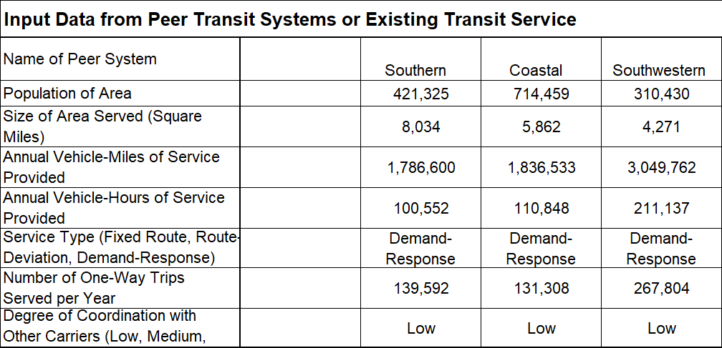

Table 5: Input Data from Peer Transit System or Existing Transit Service

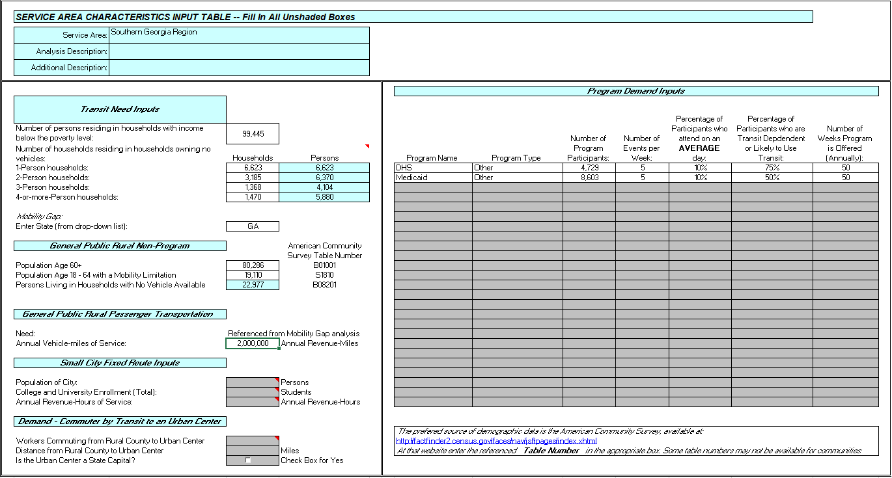

Table 6: Input Characteristics of Service Area

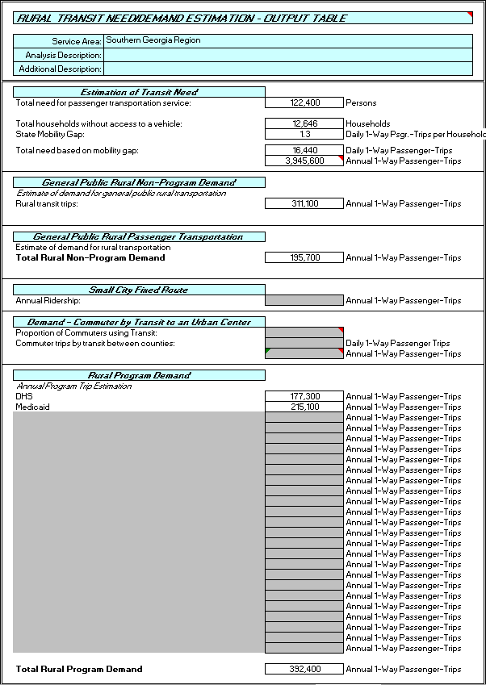

Table 7: Rural Transit Need and Demand Estimation Output Table

# Chapter 7: 5311 Financial Overview

The GDOT 5311 Budget form is divided into 30 categories of Program Operations that are reimbursed at a 50/50 Federal/Local rate. There are an additional 18 categories for Capital items including vehicles and accessories, reimbursed at an 80/10/10 Federal/State/Local rate. The following tables will display the various Program Operations categories as they appear on the GDOT 5311 grant application, adding both Southwest and Coastal Regional Commissions as a comparative measure to the SGRC’s proposed budget.

## Regional Commission Budget Comparison

The first 15 categories of the Program Operations Budget are Administrative and have been broken out by Regional Commission for comparative purposes. The first four line items are for staff salaries that will be directly responsible for the management and oversight of the regional transit system. The SGRC currently employs two individuals, Corey Hull and JD Dillard, in Director and Supervisor roles respectively, and plan to hire two additional full-time employees to work in the Transportation Department, with one financial person dedicating 100% of their time to the 5311 program (Bookkeeper), and another only 25% of their time to the 5311 program (Secretary). These titles are not exactly indicative of the roles and responsibilities but are used as they appear on the grant application. The SGRC would budget additional amounts for Training, Marketing, and Office Supplies, for the on-boarding of new staff and promotion of the regional system. These costs are expected to decrease in subsequent years. Indirect Expenses are calculated at 36%, and Fringe benefits are estimated based on current SGRC amounts.



Table 8: Regional Commission Administrative Expenses Comparison

## Third Party Operator Budget

Third party operators (TPOs) are experienced transit providers that are able to provide transit service effectively and efficiently. The bidding TPOs will be required to submit a proposed budget in the 5311 format provided in response to the Request for Proposal (RFP) process, from which TPOs will be selected to deliver the transportation services outlined in the 5311 program. The TPO Budgets below include costs to operate the GDOT 5311, DHS Coordinated Transportation, and Medicaid NEMT trips throughout the region. In the Southern Georgia region, many counties with existing rural transit systems contract with a third party operator. The SGRC would propose to continue this operating method under a regional transit system.

The TPO Admin Expenses and TPO Operating Expenses are estimated for the SGRC based on current 5311 budgets and data from prior Transit Development Plans prepared for counties without transit. The Coastal Regional Commission (CRC) and Southwest Georgia Regional Commission (SWGRC) figures in Table 9 are from current FY19 grant applications.



Table 9: Third Party Operator (TPO) Administrative Expenses Comparison

Operating costs include, but are not limited to, driver, mechanic, and dispatcher salaries, licenses, vehicle insurance, drug and alcohol testing, uniforms, maintenance and repairs (includes oil, tires, and parts) and fuel. Monthly service fees for cell phones and/or two-way radio services are eligible operating expenses.



Table 10: Third Party Operator (TPO) Operating Expenses Comparison

## Total Budget Comparison

When the sum of the RC Admin Expenses, TPO Admin Expenses, and TPO Operating Expenses are totaled, we arrive at the Total Expenses line for each regional transit program. These totals must then be reduced by the following items (See Table 11):

* Farebox Revenue for the SGRC is estimated at 4% of the total expenses based on actual recovery rates within the SGRC area. CRC collects close to 7% of its revenue from fareboxes, while SWGRC collects just under 4%.
* The Lowndes Urban Trips are those trips which begin and end within the Valdosta Urbanized Area. GDOT and FTA will not allow the costs of these trips to be reimbursed as part of the 5311 program, therefore Lowndes County is required to pay a cash match to cover these trip costs. It is proposed that Lowndes County would continue to pay this actual cash match annually as long as these trips are provided.
* The $550,000 listed under the SGRC Non-Eligible Federal Funds are the FTA 5310 funds that the SGRC receives as a part of the DHS Coordinated Transportation program contract, and are not eligible to be reimbursed as part of the 5311 program. FTA funds from different sources cannot be used to match other FTA funds.



Table 11: Comparison of Total Expenses, Net Operating Deficit Amounts, and Local Match Requirements

Federal funding may be provided for up to 50 percent of the Net Operating Deficit; the remaining 50 percent (or more) must be provided from locally-derived funds.

Based on the estimated available Purchase of Service (POS) amounts across the region from DHS, Medicaid, and Private contracts, the Local Match Available exceeds the 50% Local Match Required, meaning it is not anticipated that any county will need to pay a local match (with the exception of Lowndes for the Valdosta Urbanized Area trips). The Excess POS amount of $216,820 may be used for Future Year Capital Match or to reduce the federal drawdown amount for operating expenses.

**What if there is a shortfall of POS Revenue?**

If there is a shortfall in the amount of Local Match Available, or POS Revenue, the shortfall is proposed to be made up by each County based on the percentage of trips originating in each County. For example, if only 4% of the trips under the regional transit system begin in Brooks County, then Brooks County would only be required to contribute 4% of the shortfall amount. Therefore, if there is a $100,000 shortfall in Local Match Available, based on the 4% of the Total Trips provided originating in Brooks County, Brooks County would contribute $4,000 to the SGRC to cover the Local Match Required.

**What happens to existing county transit systems?**

Counties should give a 60-day public notice of the proposed changes and transfer their vehicles to the SGRC regional system. The County name would remain on the vehicle until the vehicle is replaced, at which time a new system name and/or logo would be applied

**What happens if a county does not opt into a regional system?**

The county is still eligible to apply for 5311 funds and is responsible for administering the system or utilizing a TPO to deliver the services just as many counties do now. In order for the county to receive any POS funds within their boundary, the county would have to bid as a TPO on the SGRC’s DHS Coordinated Transportation Services, Medicaid NEMT Services, or other eligible POS sources. Counties would be encouraged to coordinate their trips with a regional system.

**Explain 5310 amount compared to other regions**

The 5310 amount in the SGRC is higher than other regions because an urban (5307) transit system is not using the funds within the Valdosta Urbanized area, like in Albany, Hinesville, or Savannah. Therefore, the regional commission works with eligible HSPs in the Valdosta Urbanized area to utilize these funds.

**What would happen to a Regional system if an Urban System (5307 Funds) were to begin?**

Depending on how an urban system is implemented, various scenarios could occur. For example, if a local government were to begin an urban transit system, the money received from the Lowndes Urban Trips would cease and the urban 5310 funds would be utilized by the new urban transit system. Associated expenditures of trips currently on the 5311 system would also transfer to the new urban system, thus reducing the overall expenses and local match requirements.

# Chapter 8: Potential Improvements

After developing a regional transportation system, the next step would be to consider how to improve the overall quality of public transportation in the Southern Georgia region. Below is a list of potential improvements or additions to a public transit system in Southern Georgia that could help foster higher ridership and increase the overall efficiency of the regional public transportation system. These improvements should be considered over the next 5 years.

## Monthly Passes

As stated earlier in the document, transportation to and from work can be extremely costly. This is especially true for families that have access to only one motor-vehicle. Therefore, one potential way to make public transportation both more affordable and improve ridership would be to offer monthly passes to riders. Initially, these passes could be offered at monthly/weekly rates for riders who frequent the public transit system. For example, Fresno County, California offers a 7-day pass and a monthly pass for their rural transit system. Furthermore, discount passes could be offered to senior riders or riders with special needs.

## Technology Improvements

The 24-hour advance request for public transportation is one deterrent of potential riders and issue with current riders. A desire for more “real-time” transportation, like those offered by transportation network companies (TNCs) such as Uber and Lyft, can be achieved through the use of existing technology. An app for a smart device that allows citizens to request a ride and track vehicles could be integrated into a regional system to increase ridership and improve efficiency.

## Employment-Based or Sponsored Transit

One of the uses of public transportation is commuting to and from work. Businesses could subsidize the cost to transport their employees through monthly passes or vanpool programs, offering reliable transportation to make sure their employees arrive on time. These commuter benefits are eligible for tax credits as part of an employee’s fringe benefits. There are also opportunities to develop public private partnerships

# Chapter 9: Appendix

Facebook Ad results

**General Themes of Facebook Comments:**

Praise for the drivers and recognition of the training and hard work that they do

Thankfulness for the transit services

Requests for services in locations currently without transit

Desire for more real-time on-demand instead of 24-hour advance notice

